An investigation into the reading abilities in English: A case study of
a Chinese College’s English major students
(Yunnan Minzu University)

Yuanyuan Xu,^{1*} Anchalee Chayanuvat²

^{*1, 2} Bilingual Education Program, Suryadhep Teachers College Rangsit University
Muang-Ake Phaholyothin Road Lak-Hok Muang Pathumthani, Pathumthani 12000, Thailand
Corresponding author. Email: yuanyuanxu.rsu@gmail.com

Article Info:
Received: Aug 31, 2021
Revised: Dec. 16, 2021;
Accepted: Dec 20, 2021

Abstract
In fact, many Chinese students still have great difficulties in reading comprehension even after many years of English learning. Thus, the objectives of this survey study were 1) To identify the reading abilities of 285 Chinese college English major students from Year 1 to Year 4. and 2) To compare the reading abilities of students studying in Year 1 to Year 4 of a Chinese college in terms of compares their strengths and weaknesses in reading. The participants including 285 English major students from Yunnan Minzu University. A standardized English Reading Test was the main instrument used to identify the reading ability levels of these four groups. The questionnaire collects the factors that influence students’ reading speed in the test. Semi-structured interviews used to collect the students’ thoughts and opinions about the test. The findings of the study revealed that the English reading abilities of Year 1 students were significantly lower than upper years. According to the questionnaires, both junior students and senior students believed that their weak reading abilities lay in the lack of vocabulary and reading strategies. Judging from the semi-structured interview data, students' poor English reading ability is not only due to their own problems, but also due to teachers' neglect of reading strategy training and incorrect teaching methods. According to the study, students can find useful ways to improve their English reading abilities and teachers can find ways to support their students and design teaching and learning in the future.

Keywords: English reading abilities; Effective reading strategies; Chinese English major student
Introduction
Nowadays, the focus of English teaching has always been to develop the learners' ability to master four language skills: listening, speaking, reading and writing (Husain, 2015). According to Copland, Garton and Burns (2013), there are many challenges to teaching English. Four major skills for students to master are further divided into two groups. Listening and reading are grouped as the receptive skills, while speaking and writing are production skills.However, for higher education, it is obvious that university students must have good reading and writing skills to deal with the reading load of their studies because most textbooks are mostly in English, especially for English majors (Cabral, & Tavares, 2002). Writing in English is a great way to develop students’ brains ability to think in English (Adriana, 2018). Lorena (2015) claims that reading skills are the foundation and prerequisite for developing other language skills. Besides, although reading and writing are acts of communication, skilled readers learn more than the content but also sentence and paragraph structures (Schoonen, 2019)
According to Karakoc (2019) reading involves a number of subskills collected from TOEFL IBT) which consist of understanding main ideas, understanding facts and details including negative facts, making inferences about the content, identifying purposes of the author about details in content relations between ideas, understanding the meaning of unknown vocabulary, understanding pronoun reference, sentence paraphrasing, inserting
a sentence in an appropriate gap, summarizing by distinguishing major and minor ideas and cause-effect, compare-contrast relationships, arguments and so on.
For Chinese college English major students, reading ability is very important. Dealing with academic reading, students need to have good world knowledge besides an advanced level of reading skill (Sun, 2011). In the scenario, it is clearly seen that most students still feel that their reading abilities are not satisfactory after graduation. Their scores in the standardized tests are usually low. (Li, 2017) Therefore, the study focused on investigating the reading abilities of English major students in groups of four different years and finding out what reading levels they were at and what weaknesses they had. With the findings from the study, students can find useful ways to improve their English reading abilities in the future and teachers can find ways to support their students and design teaching and learning at the university to cope with the problems spotted.

Research Objectives
1. To identify the reading abilities of 285 Chinese college English major students from Year 1 to Year 4.
2. To compare the reading abilities of students studying in Year 1 to Year 4 of
a Chinese college in terms of compares their strengths and weaknesses in reading.

Literature Review
Reading is an activity in which readers respond to the text they are reading and transform it into their previous knowledge to understand the message (Safitri, 2014). Nurjana (2018) states that reading is an essential skill and is the basis for improving other skills. Li Xuemei (2018) presents in her research that reading skills are the foundation and prerequisite for developing other language skills. Reading can cultivate and enhance students' sense of language. Learning a language is very important because it determines whether the language spoken by the students is pure and authentic. Reading is the most direct and basic way to cultivate students' sense of language. Thus, reading is an essential requirement of an advanced society. (Sangia, 2014) Likewise, in education, reading has a great influence on students' performance. It can be proved that the higher students' reading comprehension ability is,
the more knowledge they acquire. Therefore, it is necessary to cultivate students' reading interest and reading skills as early as possible so that students can understand the role of reading. Good communication and learning tools can expand knowledge and skills and broaden horizons.

Theoretical Framework
The literature review consists of 5 parts, the detail show as follows:
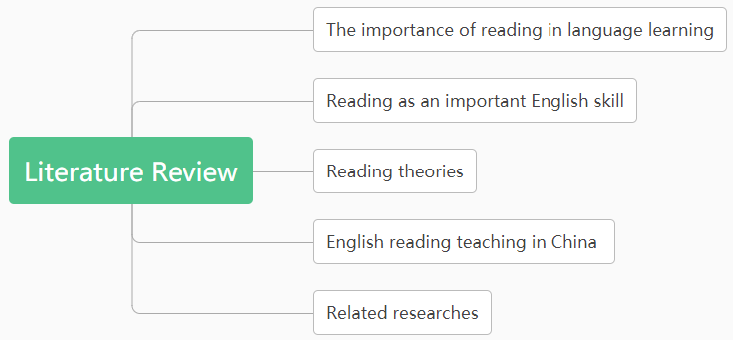
Figure 1 Theoretical Framework

Definitions of Reading Strategies
Different researchers have offered several definitions of reading strategies.Readers to solve problems and ways to obtain textual information. Cohen (2002) defines the reading strategy as a strategy in which the reader consciously performs a reading task in reading. But in this study will mainly adopt Brown (2004)’s classification of reading strategies as the foundation for an investigation of reading skill areas as well as analysis of the findings. According to Brown, the strategies used by each student are different, depending on which one is suitable for their situations. His reading strategy classification is as follows: skimming refers to students quickly read content to grasp information. Scanning means students only need to read the information points they need. Identifying the writer’s purpose in reading refers to students understand the writer’s purpose before their reading. Paraphrasing shows that the students fully understand the original meaning and express it in their own words.
The ability to guess Words means that learners guess unfamiliar words according to the context or part of speech. Inferring means taking the facts obtained from the text one step further to fully understand the writer's intentions and summarizing is the act of concluding the content of the text to understand the main points conveyed.

Research Methodology
Quantitative and qualitative data collection methods were adopted in this mixed methods study. In order to answer the research questions, this study collected data by three research instruments: 1) a standardized English reading test, included 3 passages, and a total of 42 questions. The full score of the reading paper was 42 points with the following interpretation 36 points means “excellent”, while 33-35 points means “good”, 22-32 means students “average” and 21 points or below means “poor”. 2) a questionnaire survey, after finishing the English reading test, the test takers were requested to fill out a questionnaire to give their opinions about the standardized test that they just took as well as other specific information about what reading strategies they used in tackling the questions in the test.
3) semi-structured interviews, after the examination also, aim to study the English reading abilities of English major students with a focus on their strengths and weaknesses and ways for reading skill improvement.
The population in this study consisted of the English major students in the Faculty of Foreign Languages of Yunnan Minzu University (YMU) in Kunming, Yunnan Province, China. The total number of English major students was 350 in the 2019 Academic year. For the sample selection technique and the sample size, the researcher used stratified sampling techniques to get the samples that truly represented students in the four years of the university (Burns, 2000).
For the English reading test scores, the different groups of sub-skills were compared among the four groups. The data in the format of the criterion-based test scores, marked as right and wrong, were analyzed with descriptive statistics (percentage, mean, S.D., highest and lowest scores). The questionnaire data was to give self-report evidence about how the students did the test, what they thought of it. Descriptive statistics were used it also. For the responses to the only open-ended question about how they would improve their reading abilities, frequencies of ideas were counted.The interview scripts were analyzed by content analysis. Similar thoughts were put into themes and the themes were compared and contrasted until the number was reduced to a few that would be used to answer the research questions.

Findings
Major findings that emerged from the three instruments used in the study (the English Reading Test, the Questionnaire and the Semi-Structured Interviews) are presented below.
1. Analysis of the overall reading ability levels from the English reading test
Judging from the test results, the over reading ability level of the majority of English major students from Year 1 to Year 4 was not high. Students in Year 4 scored the highest with a maximum of 35.00 and 25.00. Year 1 students scored the lowest with a maximum of 26.00 and a minimum of 18.00. The majority of Year 1 and Year 2 students obtained 65% and above (22-32) but that was only at the fair level.

Table 1 One Sample T-test of the Results of All the Students from Year 1 to Year 4
No. | Number  of Students | Mean | S.D. | Std. Error | 95% Confidence Interval for Mean |  | Minimum | Maximum
 |  |  |  |  | Lower Bound | Upper Bound
1 | 73 | 22.04 | 2.30 | .26849 | 21.51 | 22.58 | 18.00 | 26.00
2 | 83 | 25.70 | 2.39 | .26208 | 25.18 | 26.22 | 21.00 | 31.00
3 | 66 | 26.14 | 2.12 | .26067 | 25.62 | 26.66 | 22.00 | 30.00
4 | 63 | 29.28 | 2.26 | .28518 | 29.21 | 30.35 | 25.00 | 35.00
Total | 285 | 25.77 | 3.51 | .20774 | 25.36 | 26.17 | 18.00 | 35.00

When the scores of students in each year were analyzed into 4 levels: Excellent (85% up), Good (75% to 84%), Fair (65% to 74%) and Poor (50% to 64%), it was found that the total number of students that scored at the excellent level was only 16.4 % in Year 1, 22.9% in Year 2, 27.3 % in Year 3 and 31.7% in Year 4. The majority of students in Year 3 and Year 4 could score at the Good Level, while students in Year 1 and Year2 only scored at the Fair level. Although fewer students scored at the poor level, some are still believed to need help in reading skill improvement. See Table 2 below.

Table 2 Score Results from the English Reading Test of Year 1 to Year 4 Students
Scores | Year 1 | Year 2 | Year 3 | Year 4
36-42 (85%) | 16.4 % | 22.9 % | 27.3 % | 31.7 %
33-35 (75%) | 20.5 % | 24.1 % | 34.8% | 46.0 %
22-32 (65%) | 49.3 % | 36.1 % | 24.2% | 15.9 %
0-21 (50%) | 13.7 % | 16.7 % | 13.6% | 6.3 %

2. Analysis of the eight reading skills from the English reading test
By analyzing each item in the Reading Test and analyzing how students in each year performed, the findings revealed which the students mastered reading skill areas and which reading skill areas needed to be urgently improved. Based on the results shown, this group of students need to be intensively trained to improve advanced reading sub-skills such as inferring, sentence coherence, identifying the writer’s purpose and summarizing showed low scores in all levels. Although Year 4 got higher scores in various sub-skills but they were not impressive enough. See Table 3.

Table 3 Analysis of the Eight Reading Skills from the English Reading Test of Year 1 to Year 4 Students
Reading Skills | Year 1 | Year 2 | Year 3 | Year 4
Paraphrasing | 45.2% | 57.8% | 61.4% | 67.5%
Scanning | 50.8% | 63.0% | 64.4% | 78.6%
Inferring | 37.4% | 47.4% | 45.5% | 49.7%
Guessing vocabulary | 33.3% | 52.3% | 74.4% | 84.7%
Identify the writer’s purpose | 38.3% | 49.4% | 53.5% | 57.7%
Sentence Coherence | 27.9% | 45.0% | 45.5% | 52.9%
Summarizing | 37.4% | 47.4% | 49.0% | 58.2%
Referencing | 39.7% | 55.4% | 51.5% | 64.3%

As can be seen by the analysis of items in the tests, the percentages shown in Table 3 revealed that Year 4 students scored the highest in all areas, while Year 1 scored the lowest. Year 4 scored high in most items but inferring (49.7%), sentence coherence (52.9%) and identifying the writer’s purpose (57.7%) were the poorest skill areas. These students appeared to have similar weak reading skill areas which are sentence coherence, inferring and summarizing. In contrast, Year 1 students had the guessing vocabulary problem and Year 4 found identifying the writer’s problem difficult.

3. Analysis of the questionnaire responses
The questionnaire can be divided into three sections: 1) Factors that Affect Students ’ English Reading Speed 2) The Strategies Used in Trying to Understand the Text Read and 3) The Students’ Thoughts about the Test.
3.1 Personal particulars of the groups
The four groups of students that took the Reading Test had the age range between Below 18 to Above 25 as shown in Table 4. Table 5 shows the number of students in each year at the university and Table 6 shows the students’ evaluation of their English ability levels.

Table 4 The questionnaire respondents’ age range
Age Range | Number | Percentage
Below 18 | 50 | 17.54
18-21 | 95 | 33.33
22-25 | 105 | 36.84
Above 25 | 35 | 12.28

Table 5 Number of students in each year at the university
Age Range | Number | Percentage
Year 1 | 73 | 25.61
Year 2 | 83 | 29.12
ear 3 | 66 | 23.16
Year 4 | 63 | 22.11

Table 6 Average English grades
Grade | Number | Percentage
Excellent (A) | 30 | 10.50
Good (B) | 73 | 25.60
Fair (C) | 72 | 25.30
Weak (D) | 64 | 22.50
Very Weak (F) | 46 | 16.10
3.2 Factors that affect students’ English reading speed
Based on the results of Section 1 of the questionnaire survey, only freshmen chose unfamiliar vocabulary (x̄=4.04/SD=6.33) and grammar (x̄=4.38/SD=5.17) in reading as the factors affecting their reading speed at the high level. In contrast, all other factors did not seem to affect students’ reading speed in other years. The factors which gave medium effect were unfamiliar topic/content and the length of the text. Surprisingly, for all years, the language used by the author of the text was not a problem for them. Details are shown in the following table.

Table 7 Factors that Affect Students’ English Reading Speed
Items | Year 1 | Year 2 | Year 3 | Year 4
5. Unfamiliar words | x̄=4.04  S.D.=0.633  High | x̄=2.83  S.D.=1.324  Low | x̄=2.88  S.D.=1.342  Low | x̄=1.94  S.D.=0.780  Low
6. Unfamiliar topic/content | x̄=3.95  S.D.=0.664  Medium | x̄=2.83  S.D.=0.695  Medium | x̄=2.92  S.D.=0.730  Low | x̄=2.10  S.D.=0.346  Low
7. Grammar | x̄=4.38  S.D.=0.517  High | x̄=2.94  S.D.=0.612  Low | x̄=2.89  S.D.=0.558  Low | x̄=2.48  S.D.=0.503  Low
8. The language used by the author of the text | x̄=2.52  S.D.=0.503  Low | X=2.47  S.D.=0.502  Low | x̄=2.98  S.D.=0.832  Low | x̄=2.48  S.D.=0.503  Low
9. The length of the text | x̄=2.36  S.D.=0.482  Low | x̄=2.48  S.D.=0.503  Low | x̄=3.09  S.D.=0.799  Medium | x̄=2.41  S.D.=0.496  Medium

3.3 The strategies used in trying to understand the text read
As shown in Table 8, students studying in different years all chose “Read the title in order to predict the content” and “Use the background knowledge I know to predict the meaning of the text” as their main reading strategies. However, students in Year 4 used all strategies except “I read each word carefully”, which they used at the ‘Low’ level. It can be said that Year 4 students used more strategies than other students. On the contrary, Year 1, Year 2 and Year 3 students used “I read each word carefully” at the ‘High’ level.

Table 8 The strategies used in trying to understand the text read
Items | Year 1 | Year 2 | Year 3 | Year 4
10. Read the title in order to predict the content. | x̄=4.52  S.D.=0.503  High | x̄=4.47  S.D.=0.502  High | x̄=4.53  S.D.=0.503  High | x̄=4.37  S.D.=0.485  High
11. Use the background knowledge I know to predict the meaning of the text | x̄=4.45  S.D.=0.501  High | x̄=4.51  S.D.=0.503  High | x̄=4.55  S.D.=0.502  High | x̄=4.57  S.D.=0.499  High
12. Scan the text for the key words/ key information to get the answers to the questions asked. | x̄=1.96  S.D.=0.351  Low | x̄=3.48  S.D.=0.503  Medium | x̄=3.42  S.D.=0.498  Medium | x̄=4.44  S.D.=0.501  High
13. Scan the text to know the answers to the questions asked. | x̄=2.07  S.D.=0.481  Low | x̄=3.53  S.D.=0.502  Medium | x̄=3.42  S.D.=0.503  Medium | x̄=4.51  S.D.=0.504  High
14. While reading, I summarize major details that appear in the text. | x̄=1.45  S.D.=0.501  Low | x̄=3.10  S.D.=0.759  Medium | x̄=2.94  S.D.=0.830  Low | x̄=4.43  S.D.=0.499  High
15. I guess the meaning of the words I do not know from the context surrounding each word. | x̄=2.52  S.D.=0.503  Low | x̄=4.00  S.D.=0.383  High | x̄=3.92  S.D.=0.535  Low | x̄=4.43  S.D.=0.499  High
16. I read each word carefully. | x̄=4.47  S.D.=0.502  High | x̄=2.46  S.D.=0.501  Low | x̄=2.48  S.D.=0.504  Low | x̄=2.54  S.D.=0.502  Low

3.4 What the students thought about the reading test and their reading abilities
Students of the four years shared both similar and different ideas about how they looked at the Reading Test and their reading abilities in terms of the necessary sub-skills.
Table 9 What the students thought about the reading test and their reading abilities
Items | Year 1 | Year 2 | Year 3 | Year 4
17. The test is appropriate for my English level. | x̄=1.53  S.D.=0.502  Low | x̄=4.47  S.D.=0.502  High | x̄=4.53  S.D.=0.503  High | x̄=4.37  S.D.=0.485  High
18. Practice in the classroom helps me to do the test. | x̄=3  S.D.=0.501  High | x̄=4.51  S.D.=0.503  High | X=4.55  S.D.=0.502  High | x̄=4.57  S.D.=0.499  High
19. I could answer the test question. | x̄=1.96  S.D.=0.351  Low | x̄=3.48  S.D.=0.503  Medium | x̄=3.42  S.D.=0.498  Medium | x̄=4.44  S.D.=0.501  High
Table 9 What the students thought about the reading test and their reading abilities (cont.)
Items | Year 1 | Year 2 | Year 3 | Year 4
20. I need to learn more vocabulary. | x̄=2.07  S.D.=0.481  Low | x̄=3.53  S.D.=0.502  Medium | x̄=3.42  S.D.=0.503  Medium | x̄=4.51  S.D.=0.504  High
21.I need more practice in learning strategies. | x̄=1.45  S.D.=0.501  Low | x̄=3.10  S.D.=0.759  Medium | x̄=2.94  S.D.=0.830  Low | x̄=4.43  S.D.=0.499  High
22. I need more practice in inferencing skill. | x̄=2.52  S.D.=0.503  Low | x̄=4.00  S.D.=0.383  High | x̄=3.92  S.D.=0.535  Low | x̄=4.43  S.D.=0.499  High
23. Reading by translating the words/sentences into Chinese first helps me to understand the text. | x̄=4.47  S.D.=0.502  High | x̄=2.46  S.D.=0.501  Low | x̄=2.48  S.D.=0.504  Low | x̄=2.54  S.D.=0.502  Low
24. World knowledge/ Background knowledge help me to guess the content. | x̄=2.52  S.D.=0.503  Low | x̄=4.00  S.D.=0.383  High | x̄=3.92  S.D.=0.535  Low | x̄=4.43  S.D.=0.499  High
25. I have advanced English reading skills. | x̄=4.47  S.D.=0.502  High | x̄=2.46  S.D.=0.501  Low | x̄=2.48  S.D.=0.504  Low | x̄=2.54  S.D.=0.502  Low

3.5 The Open-ended Question
From the table, it can be concluded that students felt they needed to learn more reading strategies. Maybe, they found it not easy to tackle the reading texts some of which were complex and needed advanced reading strategies to help. See Table 10 below.

Table 10 The Open–ended Question
NO. | Themes | Frequencies
1 | Learn more reading strategies | 270
2 | Strengthen skimming strategies | 253
3 | Strengthen scanning strategies | 242
4 | Learning new vocabulary | 223
5 | Listening English music | 190
6 | More practice in free time | 180
7 | Reading English books | 165
8 | Watching English movies | 130
9 | Improve interest in English reading | 60

4. Analysis of the Interviewed Data
Students clearly showed their opinions towards this English Reading Test from the interviewed data. The content analysis of the interview scripts grouped similar ideas into topics revealed four interrelated thoughts on 1) The Students’ Opinion about the Reading Test 2) The Reading Strategies the Students Usually Used 3) The Items that Were Easy for Students 4) The Items that Were Difficult for Students and 5) Ways for Reading Skill Improvement in the Future.
4.1 Opinions about the Reading Test
In this study, three students in each grade were randomly selected for an interview, and a total of 12 students participated in this interview. Among them, five students thought this test was difficult, six students said it was medium and only one students said that it was easy.
4.2 The Reading Strategies the Students Usually Used
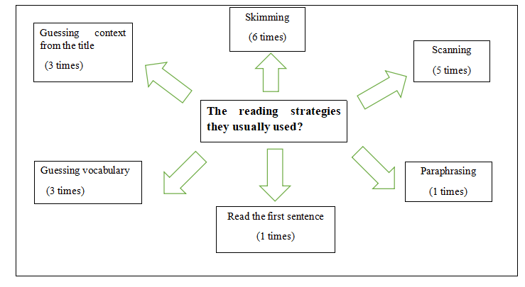
From the data, it can be seen clearly that skimming and scanning were the two most popular reading strategies among interviewees. The second most popular was to guess the context from the article title and guess vocabulary. Paraphrasing and Reading the first sentence of each line were not often used.
Figure 4.2 The Reading Strategies the Students Usually Used

4.3 The items that were easy for students
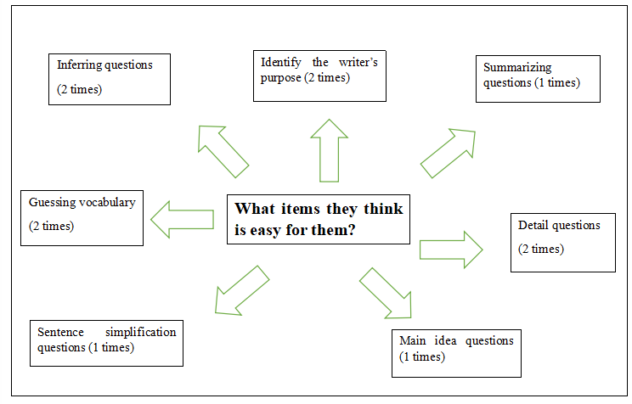
Analysis from Figure 4.4 shows that most interviewees did not share similar ideas about what type of items was easy. Students did not answer with confidence which items were easy for them. The answers were scattered: there was no obvious majority of choices with the frequency of two for guessing vocabulary, detail questions, inferring questions and identifying the writer’s purpose. The rest as sown in the figure got only 1.
Figure 4.3 The items that were easy for students

4.4 The Items that Were Difficult for Students
Based on the responses in the interviews. Many students said the test time for one hour for 42 questions was too short for them. Unfamiliar vocabulary presented a big challenge for them and so were paraphrasing and sentence insertion questions. As can be seen in the following figure, what was difficult included sentence insert questions (5 times), guessing vocabulary (4 times) and paraphrasing (4 times) to be followed by short time (3 times), identify the writer’s purpose (2 times) and length of context. Reference questions (1 time) do not seem to be a big problem.

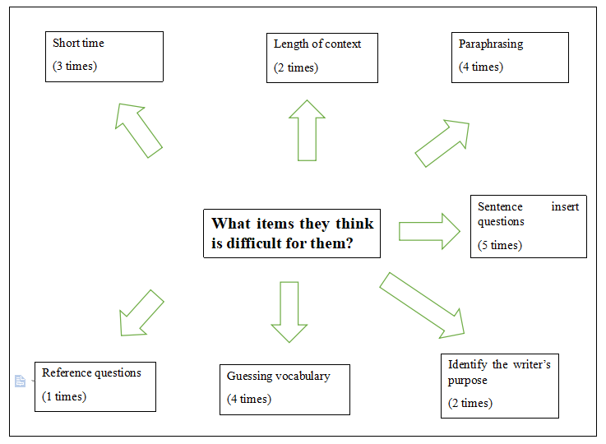

Figure 4.4 The items that were difficult for students

4.5 Ways for reading skill improvement in the future
On how to improve their English reading skills in the future, the students indicated with the frequency of 6 times that they should learn more effective reading and learn and memorize more new words (5 times). In addition to this, some students thought doing more practice in spare time (3 times) is also an exchange way to improve reading.
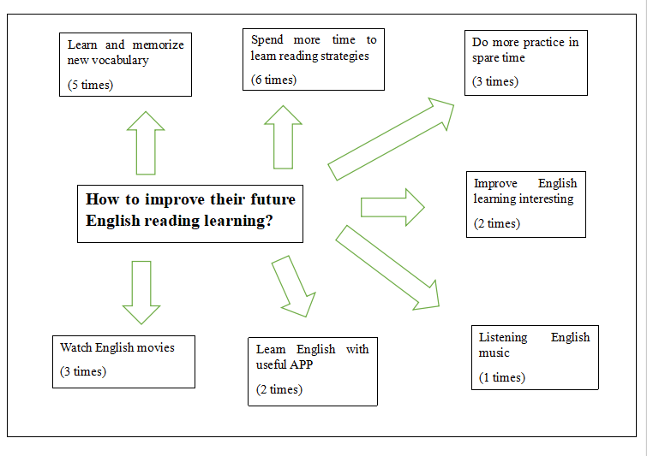
Figure 4.5 Ways for reading skill improvement in the future

Conclusions and recommendations
Responses to the study objectives, both 1 and 2, are clear-cut and explainable. The reading abilities of Chinese college English major students as can be interpreted by their earned scores in the English Reading Test (Instrument 1) show that there is ample room for improvement. Because only 77.70 % the students in the fourth year could score over 75%. For English major students, it is undeniable that their expectations are high. They are expected to have advanced reading abilities to show their mastery of the English language. This is in line with Brown (2004), who identified the reading sub-skills that all readers must master. Generally, many people believe that reading is easy to master but in fact, reading does not show a straightforward meaning represented by the words used in the texts. Words do have their different meanings depending on contexts and they have varying shades of meaning. (Lynch & Anderson, 2013) To compare the reading abilities of different levels (Year 1 to Year 4) of Chinese college English major students in reading to identify strengths and weaknesses in their reading abilities. As could be predicted but shown by the scores in the reading test, Year 4 students should score the highest because they are going to complete their bachelor’s degree in English. Their exposure time to studying English is longer than students in other years. They felt more comfortable with the test items because they found only a few difficulties. Besides, they were more familiar with the reading strategies and used more of them than students in other years. The skill areas that most students found they needed improvement were inferencing, summarizing, understanding the writer’s purpose and sentence insertion into the text, which are not easy for many people. One obvious reason for many students was found to be the short time for the test. Exposure to various types of texts as well as the world knowledge will help the students to read faster besides skimming and scanning. (Setiawan, 2019) Recommendations for the reading teachers are to give students more practices in the difficult areas and offer students training in effective reading strategies. Also, students need to do more intensive practice in reading strategies so that they can read faster and improve their vocabulary power. (Abbas, & Narjes, 2016)

References
Adriana, L. White. (2018). Why is writing important?. Retrieved from https://www.englishteacheradriana.com/
why-is-writing-important/
Abbas Pourhosein Gilakjani, & Narjes Banou Sabouri. (2016). How can students improve their reading comprehension skill. Journal of Studies in Education, 6(2), 229.
Brown, Douglas. (1994). Teaching by Principles: An interactive approach to language pedagogy.
Cabral, A. P., & Tavares, J. (2002). Reading and writing skills in higher education: Lecturers’ opinions and perceptions. Paper presented at the European Conference on Education Research, University of Lisbon, 11-14 September, 2002.
Cohen, L, Manion, L., & Morrison, K. Morrison (2002). Research methods in education (6th ed.). New York, NY: Taylor & Francis.
Copland, Garton, S. & Burns, A. (2013). Challenges in teaching English to young learners: Global perspectives and local realities. TESOL Quarterly, 48(4), 738-762.
Hossain, Mohammed Iqram. (2015). Teaching productive skills to the students: A secondary level scenario. Retrieved from https://core.ac.uk/download/pdf/74352632.pdf
Karakoc, A. I. (2019). Reading and listening comprehension sub skills: The match between theory, coursebooks and language proficiency tests. Advances in Language and Literary Studies, 10(4),
166-185.
Lorena Manaj Sadiku. (2015). The importance of four skills reading, speaking, writing, listening in a lesson hour. Retrieved from https://journals.euser.org/files/articles/ejls_jan_apr_15/Lorena_Manaj.pdf
Schoonen, R. (2019). Are reading and writing building on the same skills. The relationship between reading and writing in L1 and EFL. Reading and Writing, Springer, 32, 511-535.
Safitri, L. (2014). An analysis of reading materials on the quality of English textbook “Headline English” Published by SEWU for Grade VII Students of Junior High School. Retrieved from http://eprints.uny.ac.id/18512/1/Iis%20Safitri%2007202244075.pdf
Setiawan, A. H. (2019). Conducted a research on the use of skimming and scanning techniques in reading comprehension for TOEFL. Retrieved from https://core.ac.uk/download/pdf/293474101.pdf
Lynch, T., & Kenneth Anderson. (2013). Conducted a research on grammar for academic writing. Retrieved from https://www.ed.ac.uk/files/atoms/files/grammar_for_academic_writing_ism.pdf

Xuemei, Li. (2018). The importance of reading. Retrieved from: https://www.nordangliaeducation.com/our-schools/al-khor/parent-resources/our-school-enewsletter/primary/the-importance-of-reading

