A Model of Cultivation of the Buddhist Way of Life in a Cultural Approach to Foreign Tourists
Chatreudee Wilkie¹ Suvin Ruksat²
Graduate School, Mahamakut Buddhist University^{1,2}
Corresponding author email: Chatreudee.Wilkie@gmail.com¹Puzinnian@gmail.com²
Received 31/07/2025; Revised 14/09/2025; Accepted 16/09/2025
Abstract
This study aims to: (1) explore theoretical concepts related to cultural tourism, (2) study the cultivation of the Buddhist way of life, (3) develop a culture-based model for such cultivation, and (4) present new knowledge with practical applications. Addressing a significant research gap, the study proposes and validates a systematic framework for transmitting Buddhist values to foreign tourists through cultural engagement. A qualitative, phenomenological approach was employed, involving 45 key informants, comprising training organisers, foreign tourists, and subject experts. Data were collected through documentary analysis, participant observation, in-depth interviews, and focus group discussions, with all procedures conducted in accordance with ethical standards for human research. Thematic content analysis, inductive reasoning, and trustworthiness verification were used to ensure rigour, and findings are presented descriptively alongside a proposed model.
The results indicate that cultural tourism fosters deeper engagement with local values and traditions. In Thailand, Buddhist culture motivates tourists to explore and internalise the beliefs, practices, and aesthetic elements of Buddhist spaces. Monasteries provide structured and supportive environments for learning, particularly through the Four Foundations of Mindfulness, while monks act as facilitators who transmit essential teachings in English. The proposed culture-based model consists of four dimensions: (1) residing in peaceful environments, (2) cultivating ethical conduct through loving-kindness and role models, (3) engaging in ritual practices with meaningful explanations, and (4) reflecting on Buddhist principles such as karma, samsara, impermanence, and Nirvana. From these findings emerges the SMVIT model, Serenity, Masterpiece, Voice, and Immersion through meditation and reflection, which collectively lead to the Transformation of Worldview. This framework contributes both to cultural tourism and Buddhist education, offering temples and retreat centres practical strategies for engaging foreign tourists and fostering sustainable spiritual transformation as a form of Buddhist soft power.
Keywords: Cultural tourism; Buddhist Way of Life; Buddhist Cultivation; Transformative Learning; SMVIT model

Introduction
Global tourism rebounded strongly in 2024, with international arrivals returning to pre-pandemic scale, an outcome that renewed scholarly and managerial interest in the cultural dimensions of travel and exchange (UNWTO, 2025). Thailand remains one of the world’s leading destinations, registering over 35 million international visitors in 2024 and generating more than 1.8 trillion baht in tourism receipts, trends that position the country as a critical site for studying culturally grounded tourist experiences (Tourism Authority of Thailand, 2024).
Cultural tourism is commonly defined as travel that foregrounds engagement with a destination’s tangible and intangible heritage, its sites, practices, beliefs, and everyday living traditions, and is frequently positioned as a vehicle for mutual learning between hosts and visitors (UNWTO, 2017). In Thailand, cultural tourism often manifests as temple visits, participation in meditation programs, and attendance at Dhamma retreats; these forms of engagement provide foreigners with structured contact points for encountering Theravāda Buddhist practice and worldview (UNWTO, 2017).
Thailand’s monasteries and meditation centres have long attracted international participants. Centres associated with Buddhadāsa Bhikkhu, founder of Suan Mokkh, and well-known forest monasteries have been recognised internationally for their contribution to practice and learning; Suan Mokkh and related institutions are frequently listed among prominent global meditation centres, and Buddhadāsa has been widely acknowledged for his influence on modern Thai Buddhism. Such recognition has helped make Thailand a focal point for foreigners seeking immersive Buddhist experiences (CNN Travel, 2017).
From a pedagogical standpoint, immersive temple stays and retreats resonate with Transformative Learning theory, which locates adult perspective change in disorienting or unfamiliar experiences that prompt critical reflection and meaning reconstruction (Mezirow, 1991). Recent empirical work links immersive tourism experiences with perspective transformation and demonstrates that intentionally designed cultural encounters can function as educational interventions that reshape visitors’ beliefs and practices (Amaro, Caldeira & Seabra, 2024). Drawing on Thailand’s enduring cultural taxonomy, the moral, legal, social, and tangible dimensions articulated by the Ministry of Interior, this study examines how selected temples and meditation centres actively cultivate Buddhist ways of life among foreign tourists (Ministry of Interior, Thailand, 2008).
Despite these developments, there remains a gap: few studies have systematically identified the institutional practices, pedagogical sequences, and cultural dimensions that reliably foster the cultivation of a Buddhist way of life among foreign tourists. This study responds to that gap by examining selected Thai temples and meditation centres to develop a culturally grounded, transferable model, framed around moral, social, legal, and tangible cultural dimensions, that temples and retreat centres can use to engage foreign visitors intentionally. By linking empirical fieldwork with theory on transformative learning and soft power, the research aims to offer practical guidance for cultural tourism stakeholders and to clarify how Buddhist cultural engagement may function as a form of attraction and influence in the international arena (Phramaha Danai Srichan et al., 2024; Chaipatanapruck, 2021).

Research Objectives
1) to explore the theoretical concepts related to tourism culture
2) to study the cultivation of the Buddhist way of life
3) to develop a culture-based model for such cultivation
4) to present new knowledge and its practical application
Literature Review
Theoretical concepts in tourism culture
Cultural tourism is defined as travel motivated primarily by the desire to learn about, experience, and participate in a destination’s tangible and intangible heritage, arts, customs, beliefs, rituals, and social practices, which positions tourism as a vehicle for cultural exchange and learning (UNWTO, 2017). Cultural tourism scholarship emphasises motivations, authenticity, host–guest interactions, and the educational potential of immersive experiences. Recent work also reframes certain tourism encounters as designed “transformative experiences,” suggesting that tourism can be intentionally managed to foster lasting cognitive and affective change among visitors (Amaro, Caldeira & Seabra, 2024).
Cultivation of the Buddhist way of life in tourism contexts
In Thailand, Buddhist cultural tourism commonly includes temple visits, meditation retreats, ritual participation, and Dhamma study, forms of engagement that combine sensory, moral, and pedagogical elements (Schedneck, 2015). Ethnographic studies of international meditation centres demonstrate how these sites commodify and mediate religious practice for non-Thai visitors while also creating spaces for genuine spiritual learning; instructors, monastic routines, language accessibility, and ritual framing influence the depth of visitor engagement (Schedneck, 2015). Such findings indicate that Buddhist sites function both as cultural attractions and as informal educational settings where values, practices, and worldviews are transmitted.
Transformative learning as a conceptual lens
Transformative Learning Theory (TLT) provides a robust theoretical frame for explaining how immersion in Buddhist settings might reshape tourists’ frames of reference. Mezirow describes perspective transformation as the outcome of critical reflection following a “disorienting dilemma,” dialogic discourse, and supportive learning environments—conditions that mirror many retreat or monastic contexts where visitors encounter unfamiliar social rules and contemplative practices (Mezirow, 1991). Recent tourism research confirms that immersive, emotionally engaged experiences—when scaffolded by facilitators and reflective practices—are especially likely to generate durable shifts in values and behaviour (Wolf, 2022; Amaro, Caldeira & Seabra, 2024).
Toward a culture-based model for cultivation
Cultural frameworks developed by Thai authorities (moral, legal, social, tangible) remain useful for analysing how Buddhist life is both embodied and taught to foreigners (Ministry of Interior, Thailand, 2008). Combining these four cultural dimensions with TLT suggests a multi-layered model in which (a) tangible immersion (temple spaces, ritual forms) creates the context for (b) social learning (monastic etiquette, communal practice), (c) moral modelling (ethical teachings, merit-making practices), and (d) reflective pedagogy (guided meditation, Dhamma instruction). Empirical work on international meditation centres indicates variability across sites in the presence and quality of these elements, accounting for differences in outcomes for foreign participants (Schedneck, 2015).
Practical applications and gaps in knowledge
While scholars document the conditions under which tourism can foster transformation, there is limited systematic research identifying the specific institutional practices, pedagogical sequences, and cultural cues that reliably cultivate a Buddhist way of life among diverse foreign visitors. This gap calls for research that integrates theory (TLT, cultural tourism), field evidence from temples/retreats, and a transferable model that administrators can adopt to design intentional learning pathways, thereby operationalising Buddhist cultural engagement as both education and soft power. (Phramaha Danai Srichan et al., 2024).

Buddhist principles constitute the core teachings that have profoundly shaped the Thai way of life and served as the authoritative guide for practitioners following the Buddha’s passing. Instead of appointing a successor, the Buddha famously declared that the Dhamma and Vinaya, comprising his teachings and monastic discipline, would collectively serve as the teacher (DN 16).
Living in harmony with the Dhamma is believed to bring deep insight into life and promote right view, personal well-being, and social harmony. These benefits are understood to manifest on three distinct levels:
1) Immediate Benefit (Diṭṭhadhammikattha): Well-being attainable in this life, which includes access to basic needs, financial stability, social respect, a harmonious family life, and good companionship.
2) Future Benefit (Samparāyikattha): Attaining a favourable rebirth, inner peace, a virtuous character, and continued spiritual progress.
3) Highest Benefit (Paramattha): The ultimate goal of Nibbāna, freedom from suffering, defilements (kilesa), and attachment, characterised by radiant joy (Somdet Phra Buddhaghosacarya [P.A. Payutto] 1984).
Given that many of these principles are deeply integrated into Thai culture, this study focuses on several key teachings that inform both belief and practice:
1) The Four Principles of Faith (Saddhā): These principles centre on faith in the Buddha’s enlightenment, the law of karma, and the consequences of actions, thereby forming the foundation of Buddhist ethical life (MN 70).
2) The Six Principles of Reverence (Gārava): These involve respect for the Buddha, Dhamma, Saṅgha, the training (sikkhā), earnest effort (appamāda), and hospitality (paṭisanthāra), fostering moral integrity and communal harmony (AN 6.32).
3) The Six Directions of Social Conduct (Siṅgālovāda Sutta): These outline the ethical duties in six key social relationships—parents/children, teachers/students, spouses, friends, employers/employees, and monastics/laypeople, promoting social stability (DN 31).
4) The Four Foundations of Mindfulness (Satipaṭṭhāna): Contemplation of body, feelings, mind, and mental objects, forming the basis of insight meditation (Vipassanā), leading to Nibbāna (DN 22).
Cultural tourism in Thailand, centred on temple visits, meditation retreats, and Dhamma study, offers foreigners immersive opportunities for meaningful engagement. Transformative Learning Theory explains how scaffolded monastic experiences can trigger critical reflection and lasting shifts in perspective. However, few studies systematically identify the institutional practices and pedagogical sequences that reliably cultivate a Buddhist way of life among foreign visitors.
Conceptual Framework
In this study, the researcher examines the Buddhist way of life in Thailand based on the enduring cultural framework established by the Ministry of Culture in 1952 (B.E. 2495), still featured in Thai educational materials today, in order to ensure cultural relevance within the Thai context. The study also explores the transformation of conceptual paradigms by integrating Western academic thought from Jack Mezirow’s transformative learning theory, which is a key framework for adult learning and personal change. Furthermore, the research investigates core Buddhist principles that encompass both theoretical understanding and practical application, namely: the Four Principles of Faith, the Six Principles of Reverence, the Six Directions of Social Conduct, and the Four Foundations of Mindfulness. These are the heart of the root Thai culture and form the basis of the study’s conceptual framework.

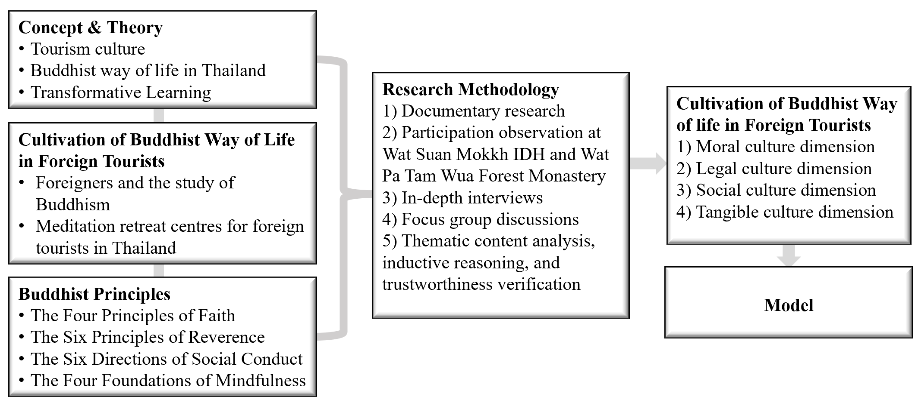

Figure 1: A Conceptual Framework for Cultivating the Buddhist Way of Life among Foreign Tourists through A Cultural Approach

Research Methodology
This study employed qualitative phenomenological field research methods to investigate how the tourism context, Buddhist principles, and transformative learning culturally emerge within Dhamma retreats in Thailand. The research process is divided into 3 steps as follows.
1) A comprehensive documentary review of related concepts and theories, the specific contexts of Wat Suan Mokkh IDH and Wat Pa Tam Wua Forest Monastery, and core Buddhist principles. Insights from this review constructed a framework that guided the fieldwork.
2) Data collection employed three primary methods: participant observation, in-depth interviews, and focus group discussions. The selection of the 45 key informants was conducted through purposive sampling, targeting individuals with rich, direct experience relevant to the research questions. In-depth interview and focus group discussion protocols were designed with open-ended questions to explore lived experiences deeply, with data collection continuing until theoretical saturation was reached, indicating that no new themes were emerging from the data. The full observation and interview protocols were submitted to the Human Research Ethics Committee of Mahamakut Buddhist University and received approval on September 24, 2024. All research activities were conducted in accordance with established ethical guidelines for human subjects.
Table 1: Key Informants
Key Informants Site/ Group | Training Organizers | Foreign Tourists | Experts
Wat Suan Mokkh IDH  (in-depth interviews) | 7 | 11 | -
Wat Pa Tam Sua Forest Monastery  (in-depth interviews) | 7 | 11 | -
Experts (individual in-depth interview) | - | - | 3
Focus group discussion participants |  |  | 6
Total | 14 | 22 | 9
Grand Total | 45

3) The resulting data were analysed using a thematic analysis coding scheme. This involved a multi-stage process of data familiarisation, initial code generation, searching for themes, reviewing themes, defining and naming themes, and producing the final report. Strategies for ensuring trustworthiness were employed, including data triangulation and member checking (presenting findings to participants for validation). This analytical process aimed to identify patterns and themes related to the cultivation of a Buddhist way of life among foreign tourists through culturally embedded approaches.
Research Results
Objective 1. This study defines tourism culture as the socially learned values, norms, and practices that shape tourist-host interactions and mediate cultural transmission (UNWTO, 2017). Historically, travel evolved from commerce, pilgrimage, and health journeys to leisure, experiential, and sustainable tourism; in Thailand, modern tourism expanded from elite and missionary movements during the reign of King Rama III into a major state-supported industry (Manophatthana, 2004; Ministry of Interior, Thailand, 2008).
Empirical evidence from interviews, observations, and document analysis shows that Buddhist cultural tourism in Thailand is organised into three principal modalities:
- Appreciation of Buddhist material culture, visits oriented to monuments, temple architecture, iconography, and museum collections. These encounters are primarily aesthetic and heritage-driven but often open pathways to interpretive learning when mediated by guides or interpretive materials (Phrasuthiratanabundit, Jinabuddhisiri Congboonwasana, & Puccantasenoet, 2017).
- Participation in faith-based ceremonies, attendance at rituals, merit-making events, and seasonal observances. Such participation exposes visitors to social norms, monk–layperson relations, and ritual scripts that convey moral and cosmological meanings embedded in everyday Thai life (Ministry of Interior, Thailand, 2008).
- Engagement in Buddhist practice for personal growth, structured retreats, meditation courses, and dhamma study aimed at inner development. These experiences are characterised by extended embodied practice, guided reflection, and pedagogical scaffolding that can produce cognitive and affective change in tourists (Schedneck, 2015).
Fieldwork further reveals that while natural beauty and heritage remain key attraction drivers, visitors increasingly value (a) accessible, low-cost living conditions and (b) the interpersonal warmth and hospitality of Thai hosts, factors that facilitate longer stays and deeper engagement. Cultural tourists frequently express motivations beyond sightseeing: expanding worldview, pursuing contemplative practice, and seeking ethical or psychological resources not readily available at home. These motivations interact with site-level factors (language accessibility, teacher competence, accommodation quality) to shape the depth and durability of cultural learning.
In sum, Objective 1 confirms that tourism culture in Thailand is multi-dimensional, encompassing historical trajectories, institutional arrangements, material expressions, ritual practices, and pedagogical processes and that Buddhist cultural tourism functions both as heritage consumption and as a potential channel for value transmission and personal transformation.
Objective 2. The results showed that historical evidence corroborates that foreigners have travelled to Asia to study Buddhism for over seven centuries. This phenomenon is often driven by a recognition of suffering and the desire to transcend it, along with a quest for life’s deeper truths. Thai people are known for their kindness, and Thai monastics are often regarded as admirable spiritual models. In recent years, increasing numbers of foreign visitors have come to Thailand for Buddhist retreats. In response, more Dhamma practice centres have emerged, each with distinct methods and formats.
One participant noted, “I came to attend the training specifically to deepen my meditation practice to cultivate wisdom. I enjoy studying Buddhism because it provides a clear, systematic path of learning.” (Field Notes, November 11, 2024).
Ethnographic observation at two prominent sites reveals contrasting institutional models. Wat Suan Mokkh International Dharma Hermitage (IDH) delivers Ānāpānasati within a regimented, school-like retreat framework, fixed schedules, explicit curricula, and spaces set apart from routine temple life, whereas Wat Pa Tam Wua Forest Monastery emphasises a more open, nature-integrated monastic rhythm that imitates traditional forest-dwelling practice. A comparative synthesis of these approaches is provided in the table below, highlighting how institutional design shapes pedagogical aims, participant experience, and potential outcomes for transformational learning.

Table 2: Comparative Synthesis of Wat Suan Mokkh IDH and Wat Pa Tam Wua Forest Monastery
Feature | Wat Suan Mokkh IDH | Wat Pa Tam Wua Forest Monastery
Format | Highly structured, 10-day retreat with a fixed curriculum and schedule | Flexible, immersive experience; visitors join ongoing monastic life
Entry Rules | Fixed start dates; must register for the full 10-day program | Can join on any day; maximum 10-day stay due to high demand
Fees | Fixed fee of THB 2,000 for the 10-day retreat (covers lodging/meals) | Free of charge; lodging and meals are provided, donations are voluntary
Dress Code | Modest dress required; white clothing is optional | White clothing is mandatory (provided by the monastery)
English Resources | Structured teachings with audio guidance in English | Monks teach and guide in English; English-speaking volunteers assist

A comparative analysis of Wat Suan Mokkh International Dharma Hermitage and Wat Pa Tam Wua Forest Monastery highlights shared success factors: visionary leadership, supportive teams, English-language resources, and exemplary monastic role models (Schedneck, 2015; Seeger, 2018). Participants consistently emphasised the monks’ selflessness, hospitality, and dedication to daily training (Phrakru Vimolbhavanausas, personal communication, November 3, 2024). Both centres also feature designated practice areas, simple facilities, clear dress codes, teachings rooted in the Four Foundations of Mindfulness, and the practice of noble silence. Volunteer service and non-profit operations reinforce authenticity and sustainability (Norman, 2017).
Immersive residency in serene, natural, and secluded environments proved to be a crucial factor in enabling participants to cultivate mindfulness, engage in deep self-reflection, and experience authentic cultural immersion (Amaro et al., 2024). These settings, characterised by simplicity, beauty, and tranquillity, create conditions conducive to inner calm, allowing individuals to temporarily step away from the distractions of modern life. The natural surroundings, coupled with structured daily routines, foster a heightened awareness of both inner states and external environments, reinforcing the integrative relationship between Buddhism, nature, and personal well-being.
Most participants were under the age of 30 and came predominantly from European countries, with Germany frequently noted as a place of origin. Their pathways to participation were informal and community-driven, relying largely on word of mouth, online platforms, and personal recommendations rather than formal tourism channels. Such organic discovery reflects the trust-based networks and perceived authenticity associated with Buddhist retreats.
The reported outcomes extended beyond temporary well-being. Participants consistently highlighted a deeper understanding of Buddhist teachings, increased mindfulness and emotional regulation, renewed appreciation for simplicity and nature, and opportunities for engaging in meaningful, purposeful activities unavailable in their home environments (Chen et al., 2025; Wolf, 2022). Many also described forming enduring friendships and supportive spiritual networks, which sustained their motivation to continue practice after returning home. In this way, the retreats function not only as short-term experiences but as catalysts for long-term personal transformation and cultural exchange.
Objective 3. The result shows 4 dimensions for cultivating a Buddhist way of life in foreign tourists as follows:
Cultivating a Buddhist Way of Life in Foreign Tourists: The Moral Culture Dimension:
Effective training programmes should incorporate core Buddhist beliefs such as karma, realms of existence, the cycle of rebirth (Saṃsāra), the Three Characteristics (Tilakkhaṇa), and Nibbāna. These doctrines form the basis of the Buddhist way of life and help foreign visitors understand foundational Thai cultural values. It is crucial not to teach only what may be immediately appealing to tourists, as this risks presenting a distorted or “whitewashed” version of Buddhism. Furthermore, introducing the concept of Nibbāna is essential, as it sets Buddhism apart from other religions and highlights its profound influence on Thai life. The Four Foundations of Mindfulness (Satipaṭṭhāna), regarded as the direct path to Nibbāna, are widely taught in Thai meditation centres.
Because these beliefs are abstract, clear and effective communication is paramount. Recommended methods include:
1) Explaining the Dhamma in simple English and using varied explanations suitable for a culturally diverse audience of non-native speakers;
2) Applying scientific reasoning and utilising relatable real-world examples or local case studies, while simultaneously promoting critical thinking and personal reflection over blind belief or forced conversion;
3) Facilitating questions and discussion to ensure deeper understanding;
4) Allowing adequate time for reflection, as internalising beliefs is a gradual process. Noble silence and contemplative practice are key tools for reviewing learned material and exploring one’s own inner landscape of thoughts and emotions.
Cultivating the Buddhist Way of Life in Foreign Tourists: The Legal Culture Dimension
The cultivation of legal culture in the Buddhist context encompasses the social customs and rituals that govern relationships in Thai society, such as those between teachers and students, or between monastics and laypeople. It also involves practices associated with other realms of existence, such as merit dedication and the practice of extending loving-kindness (mettā). A final aspect is direct participation in Buddhist ceremonies such as almsgiving, chanting, and activities on holy days. Foreign tourists can encounter and participate in these customs directly at monasteries or meditation centres.
To facilitate this cultural integration, the study identified three primary approaches:
1) Conducting an orientation session to establish a shared understanding of rituals, clarify expectations, and explain customary behaviours. Both Wat Suan Mokkh IDH and Wat Pa Tam Wua Forest Monastery utilise fluent English-speaking volunteers (notably, often German nationals) to perform this crucial task, effectively bridging the cultural gap on the day of arrival.
2) Facilitating repeated exposure to real-life contexts. For instance, observing monks on alms rounds, or bowing to the teacher in the Dhamma hall, allows tourists to absorb local customs organically.
3) Encouraging consistent hands-on practice, such as chanting, food offering, or practising loving-kindness meditation, deepens internal engagement. Over time, this process enables tourists to adopt these behaviours not merely by imitation but through sincere understanding and appreciation.
Cultivating the Buddhist Way of Life in Foreign Tourists: The Social Culture Dimension
The cultivation of social culture focuses on appropriate etiquette within the temple context, which includes demonstrating respect for the Buddha, Dhamma, and Saṅgha, and promoting harmonious communal living. These are inherently embedded in the daily routines of Dhamma centres in Thailand. The study identified several key methods:
1) Fostering Group Unity: This is achieved through shared practices, such as the uniform wearing of simple white clothing and engaging in synchronised activities like group walking meditation or chanting. Such practices help to cultivate a sense of belonging and collective discipline.
2) Practising Cultural Sensitivity: This involves recognising that foreign participants may unintentionally violate norms due to unfamiliarity. It is recommended that trainers offer gentle corrections with patience and avoid harsh criticism.
3) Extending Unconditional Hospitality: This principle, akin to treating guests as family, involves extending loving-kindness (mettā) and compassion (karuṇā) to people of all nationalities and religions. The aim is to create a supportive environment that helps alleviate their personal struggles and support their journey toward inner peace. A key manifestation of this giving without expectation of return, for example, is by offering training programs free of charge or on a non-profit basis. This approach was found to foster profound appreciation and respect from the tourists.
Cultivating the Buddhist Way of Life in Foreign Tourists: The Tangible Culture Dimension
The cultivation of tangible culture pertains to the material aspects of Buddhist practice, such as temples, daily-use structures, and Buddha images. The study identified three key methods:
1) Promoting Immersive Living: This involves inviting foreign tourists to reside within the peaceful and natural monastery settings. This approach allows them to experience the physical environment and sacred objects as part of their daily life, thereby fostering a sense of harmony with the Buddhist way of life.
2) Providing Guided Interaction with Scared Spaces and Objects: This method involves Thai hosts or volunteers demonstrating and explaining the proper use of various items, such as striking the large temple bell to signal mealtime or mark the beginning of a group activity, ensuring that their meaning and function are clearly understood.
3) Reflecting Inner Values through External Symbols and Role Models: The presence of cross-cultural role models, particularly Western volunteers who live and serve within these monasteries, helps bridge cultural gaps and encourages openness among new participants. Furthermore, observing authentic Thai devotion, such as silent reverence within temple grounds or heartfelt prostrations before Buddha images, viewed not as enforced rituals but as genuine expressions of faith, leaves a profound impression on foreign visitors. This fosters a deeper appreciation for the spiritual and cultural significance embedded within the material aspects of Thai Buddhism.
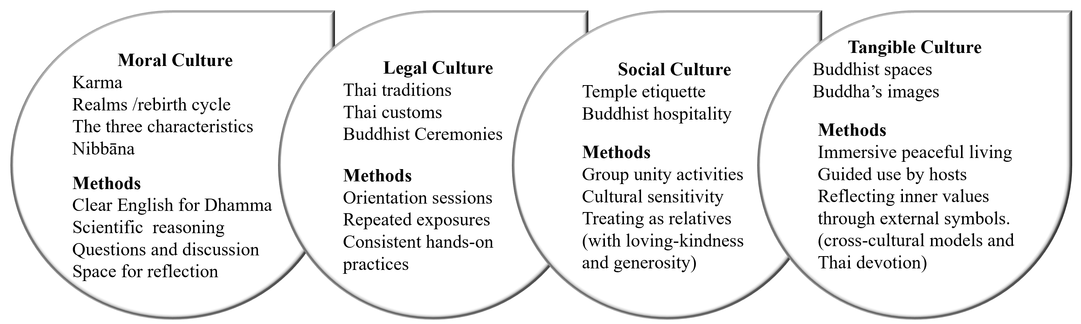Figure 2: A Summary of Contents and Methods of Cultivating a Buddhist Way of Life among Foreign Tourists through A Cultural Approach
In summary, the content (what) and methods (how) of cultivating a Buddhist way of life, as identified in this study across four cultural dimensions, are illustrated in the diagram below.
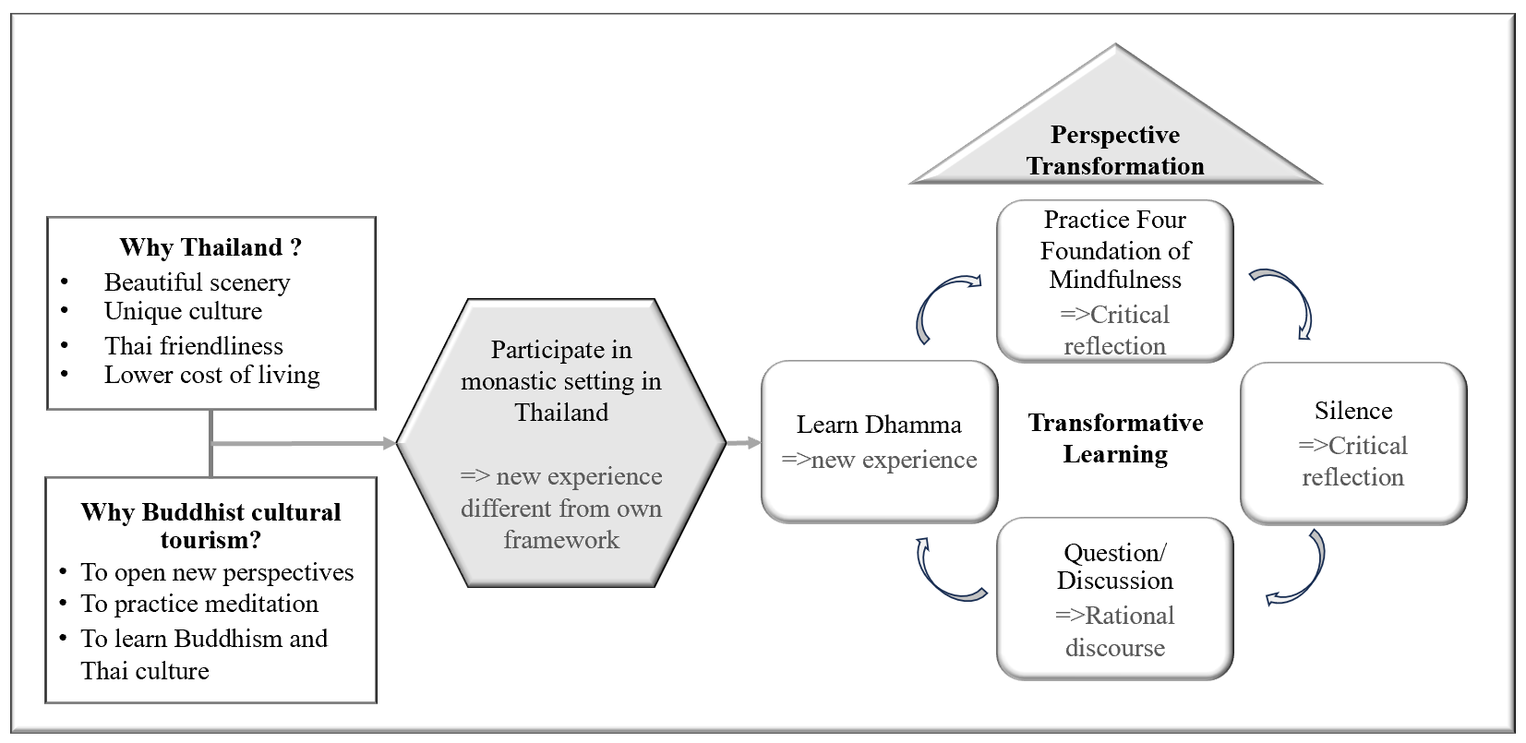Figure 3: The Intersection of Buddhist Cultural Tourism and Transformative Learning in Thailand
Overall, entering a monastic setting can create a significant cultural dissonance for most foreign tourists, which prompts profound reflection through the practice of noble silence and meditation. Inquiry and dialogue then serve as essential tools for facilitating rational discourse, ultimately leading to a transformation of the tourists’ meaning perspectives. Participants' testimonies confirm that they gained a deeper understanding of Buddhist teachings applicable to their daily lives. These findings align closely with the transformative tools outlined in Jack Mezirow’s Transformative Learning Theory. The concluding diagram illustrates this study’s synthesised model of the relationship between Buddhist cultural tourism and transformative learning.
Discussions
The study highlights that Thailand’s appeal for international tourists extends beyond its natural beauty and cultural uniqueness, long celebrated since the reign of King Rama III, to include opportunities for transformative experiences rooted in spiritual development. For many visitors, meditation retreats, Buddhist teachings, and immersion in monastic environments offer activities unavailable in their home countries. These practices allow participants to combine cultural exploration with personal growth, reinforcing the increasing importance of spiritual and wellness tourism in global travel (Norman, 2017; DSouza & Shetty, 2024). Thailand’s Buddhist heritage thus positions the country as a significant site where cultural tourism and transformative learning intersect.

The SMVIT Model in Relation to Cultural Dimensions and Prior Frameworks
Although prior models of spiritual or wellness tourism exist, the SMVIT model distinguishes itself through its integration of Mezirow’s Transformative Learning Theory (Mezirow, 1991) with the four cultural dimensions defined by the Ministry of Culture of Thailand: moral, legal, social, and tangible. This synthesis creates a culturally grounded and pedagogically coherent framework, aligning universal principles of adult learning with Thailand’s unique cultural identity (Phrasuthiratanabundit, Jinabuddhisiri Congboonwasana & Puccantasenoet, 2017). In doing so, the model advances previous research by operationalising cultural values into practical components for tourism and religious education.
The findings further suggest that the ideal context for implementing the SMVIT model involves retreat settings that are both accessible and secluded, situated in natural, serene, and clean environments. Nonetheless, its application may vary depending on institutional resources. Smaller urban temples, for example, may face challenges in fully realising the Serenity dimension due to environmental constraints. In such cases, the model allows for adaptive emphasis on other components, such as Masterpiece (the quality and inspiration of teachers) and Voice (clarity of instruction and intercultural communication).

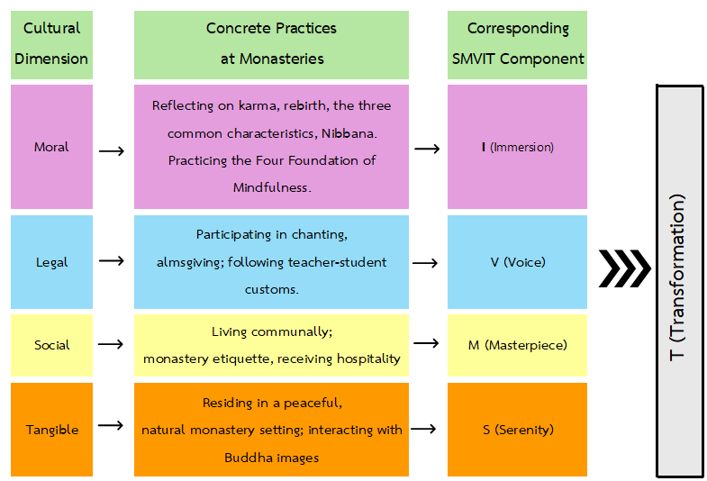
Figure 4: Mapping Cultural Dimensions, Practices, and the SMVIT Model
The study acknowledges that the model’s effectiveness is influenced by boundary conditions, including tourists’ prior meditation experience, initial motivations, and length of stay. These factors underscore the need for flexibility in program design and point toward avenues for further research on tailoring Buddhist cultural tourism to diverse audiences (Wolf, 2022; Christou, Pericleous & Singleton, 2023).
Knowledge from Research
The study demonstrates that cultivating the Buddhist way of life through an integrated, culture-based approach produces a substantive transformation of worldview, shifting participants from ordinary, self-centred perspectives toward ethically informed, liberative orientations. This process is enacted through four interdependent elements. Serenity provides a tranquil, minimally material setting conducive to reflection and communal support. Masterpiece denotes exemplary teachers and a pedagogical intention rooted in loving-kindness rather than commercial gain. Voice emphasises clear, accessible instruction and opportunities for dialogue that enable intellectual understanding to become embodied practice. Immersion comprises sustained mindfulness practice and Dhamma reflection, wherein deep meditative experience consolidates cognitive and affective change. Together, these components form a practical framework for designing programs that cultivate enduring spiritual growth and cross-cultural ethical formation among foreign visitors.
A model illustrating the cultivation of a Buddhist way of life in foreign tourists has been developed through a cultural approach, as shown below.

Figure 5: The SMVIT Model for Cultivating the Buddhist Way of Life in Foreign Tourists through a Cultural Approach
The SMVIT model represents a transformative learning cycle designed to cultivate a Buddhist way of life within foreign tourists through four cultural dimensions. It consists of four interrelated elements that nurture the journey toward a transformative worldview regarding the nature of life.
S = Serenity: Entering into a peaceful and supportive environment.
M = Masterpiece: Learning through exemplary role models.
V = Voice: The power of impactful communication.
I = Immersion: Deep meditative experiences and Dhamma reflection.
T = Transformation: A fundamental shift in one’s worldview regarding
the nature of life.
This cycle integrates external practices with internal realisation, capturing the essence of Buddhist transformative learning.
Application of New Knowledge
The “SMVIT Model” can be applied in two main ways:
1) As a guideline for training programs: Temples or meditation centres that are beginning to welcome foreign tourists can use the components of the SMVIT Model as a foundational framework. This includes selecting or developing the qualities of facilitators, designing course content and activities, methods of Dhamma transmission, schedules for meditation practice, and creating an environment and setting that best support the cultivation of the Buddhist way among international visitors.
2) As a tool for assessment and development: For temples or centres already receiving foreign tourists, the SMVIT Model can serve as a “quality assessment framework” to evaluate current operations and improve each component to align with the genuine goal of cultivating the Buddhist path.
3) As a framework for curriculum development: The model can be used to design courses or training modules in fields such as Buddhist studies, intercultural communication, or spiritual tourism, providing a structured approach to teaching transformative cultural experiences.
The SMVIT Model offers not only a clear conceptual framework but also a practical, evidence-based tool, validated for its alignment with core Buddhist principles, its foundation in transformative learning theory, and its adaptability to international contexts, as demonstrated by the two successful temples studied in the field research.
Conclusion
This study fills a clear gap by presenting the SMVIT model, an evidence-based framework for cultivating the Buddhist way of life among foreign tourists through a cultural approach. Integrating core Buddhist teachings with principles of transformative adult learning, the model identifies four mutually reinforcing dimensions: Serenity (a calm, supportive environment), Masterpiece (meaningful ritual and aesthetic encounters), Voice (clear, compassionate instruction and role modelling), and Immersion (sustained meditative practice and guided reflection), that together facilitate deep cognitive and affective shifts.
Findings show that successful cultivation requires more than exposure to rituals or monuments: it depends on intentionally designed experiences that scaffold reflection, ethical practice, and embodied contemplative methods. When these elements are present, visitors transition from external appreciation to the internalisation of Buddhist perspectives, resulting in changes in values, behaviour, and life orientation. The SMVIT model thus translates abstract doctrinal elements into practical program components that temples, retreat centres, and cultural tourism managers can adopt and adapt.
Practically, the model guides program design (space, schedule, pedagogy), staff training (communication, intercultural facilitation), and assessment (outcome indicators for wellbeing and worldview change). It also frames cultural tourism as an educational and ethical enterprise that can foster cross-cultural understanding and sustainable engagement rather than commodified consumption.
The SMVIT model advances scholarship by offering a replicable pathway to cultivate spiritual growth through tourism and provides practitioners with actionable strategies to create meaningful, transformative experiences for international visitors. Future work should test the model across diverse sites and populations to refine implementation practices and measure longer-term impacts on personal development and community wellbeing.
Abbreviations
AN Anguttara Nikaya
DN Digha Nikaya
MN Majjhima Nikaya
References
Amaro, D., Caldeira, A. M., & Seabra, C. (2024). Transformative experiences in tourism: A conceptual and critical analysis integrating consumer and managerial perspectives. Tourism and Hospitality Research. Advance online publication. https://doi.org/10.1177/14673584231182971
Chaipatanapruck, K. (2021). The guidelines of monastery management for spiritual tourism: A case study of Wat Pa Tam Wua, Mae Hong Son [Doctoral dissertation, Mahachulalongkornrajavidyalaya University].
Chen, Y. H., Hsu, H. Y., Lin, S. H., & Chen, C. H. (2025). Cultivating mental wellness through Zen meditation retreats for the general population. Tourism Management Perspectives, 45, 100–110. https://doi.org/10.1016/j.tmp.2025.100110
Christou, P. A., Pericleous, K., & Singleton, A. (2023). Spiritual tourism: understandings, perspectives, discernment, and synthesis. Current Issues in Tourism, 26(20), 3288-3305.
CNN Travel. (2017, June 15). 10 of the world’s best meditation retreats. CNN Travel. https://edition.cnn.com/travel/article/best-meditation-retreats/index.html
DSouza, K. J., & Shetty, A. (2024). Tourism and wellbeing: curating a new dimension for future research. Cogent Social Sciences, 10(1), 2319705. https://doi.org/10.1080/23311886.2024.2319705
Manophatthana, P. (2004). Introduction to the tourism industry (4th ed.). Bangkok University.
Mezirow, J. (1991). Transformative dimensions of adult learning. Jossey-Bass.
Ministry of Interior, Thailand. (2008). History of the Ministry of Culture. https://moi.gcc.go.th/index.php?Itemid=319&catid=261%3A2008-06-24-06-59-16&id=4351%3A2020-02-24-04-14-52&option=com_content&view=article
Norman, W. C. (2017). Meditation retreats: Spiritual tourism well-being interventions. Tourism Management Perspectives, 24, 25–32. https://doi.org/10.1016/j.tmp.2017.07.001
Phramaha Danai Srichan, Phra Thongjaroen Khotdinkhao, Phramaha Sarayut Nonthapa, Phra Dhammanan Sankaew. (2024). The Soft Power of Buddhism: Fostering Social Harmony and Cultural Identity in Thai Society. The Journal of International Buddhist Studies College (JIBSC), 10(1-2), 301-319.
Phrasuthiratanabundit, Jinabuddhisiri Congboonwasana, P. M. S., & Puccantaseno, P. M. S. (2017). Religious and cultural tourism: Policy impact and network management for promoting consciousness of histories and culture in ASEAN community [Research report]. Buddhist Research Institute, Mahachulalongkornrajavidyalaya University.
Schedneck, B. (2015). Thailand’s international meditation centers: Tourism and the global commodification of religious practices. Routledge.
Somdet Phra Buddhaghosacariya (P. A. Payutto). (1984). Characteristics of Buddhist society. Komol Kimthong Foundation.
Tourism Authority of Thailand. (2024, December 28). Thailand welcomes over 35 million visitors in 2024: A milestone paving the way for 2025. https://www.tatnews.org/2024/12/thailand-welcomes-over-35-million-visitors-in-2024-a-milestone-paving-the-way-for-2025/
UNWTO. (2017). Tourism and culture. https://www.unwto.org/tourism-and-culture
UNWTO. (2025). International tourism recovers to pre-pandemic levels in 2024. https://www.unwto.org/news/international-tourism-recovers-pre-pandemic-levels-in-2024
Wolf, I. D. (2022). Perspective transformation and transformative learning in tourist experiences: A systematic literature review and conceptual framework. Journal of Hospitality and Tourism Management, 52, 265–277. https://doi.org/10.1016/j.jhtm.2022.07.009

